Vibration Sensors

  - 





Francisco Marques Nº 2872
Leonel Caetano Nº 2877
Starts: 03/06/2015 Finish: 30/07/2015

Index
Introduction 5
First Part 6
What is a Sensor? 6
Characteristics! 6
What is a Vibration? 6
Which vibration sensors are most commonly used? 6
What is an Accelerometer? 7
Types of accelerometers 8
Which one is the best for vibration measurement? 8
Second Part 9
Components 9
BOM 12
Circuits 13
Circuits schematic 13
Power Circuit 13
Ampop Circuit 13
Alimentation Circuit of Battery 14
Alimentation Circuit of Arduino 14
Circuit of Max9814 15
Circuit of RGB 15
Circuit Wizard Program 16
PCB – Printed Circuit Board 17
All 17
Names and values (without vias) 17
Only Vias 17
Place Only 17
Eagle Program 18
Third Part 19
Programming 19
Arduino Software 19
FreqMeasure Library 19
Online PHP Files 19
Videos Demonstration 21
Fourth Part 22
Box Design 22
Box 22
Box Cover 22
Sketchup Software 23
3d Printer Software 23
The box in the software of the 3D printer 24
Fifth Part 25
Final Product 25
Sixth Part 26
Website 26
Seventh Part 27
Gallery 27
Eight Part 28
Conclusion 28

Introduction

This work is about a Vibration Sensor, to make the Sensor we searched in the internet which is the best Sensor, circuits of gain, programation of Arduino.
With the information that we collected from the internet we made the Circuit of gain and the programation of the Arduino.
We made a box in the 3d printer for the Sensor.
The teacher made the internet website.
The objective of this work is use the Sensor in the engine to calculate the frequency to tell us if the engine is running good or bad. If you have a problem in a production line, with this Sensor is easier and faster to detect if the anomaly is in the engine.
This document is organized in Eighth parts.
In the first part we will talk about what is a Sensor and a Vibration and then we will talk about accelerometers.
In the second part we will talk about the components we used and the circuits schematic we made and the software we used to do it, and the circuits in PCB and the software we used to do the PCB.
In the third part we will explain the programation and we will talk about the Arduino Yun.
In the fourth part we will talk about the box and the 3D printer (Makerbot Replicator2).
In the Fifth part we will talk about the final product.
In the Sixth part we will talk about the Website.
In the Seventh part we will show some photos about the project.
In the Eight part we will made the conclusion

Key words: Sensor, Vibration, Arduino, Website, Box, Circuits, Chip, Components.

First Part

What is a Sensor?

A Sensor can be defined as a device capable to make certain features, like read signals, which is normally controlled by analog gates but it is also possible in digital gates. Nowadays there are important sectors that begin to depend on sensors for various applications, like for example medicine, robotic and general industries.
Most sensors work in response to an external stimulus, that is, the energy that it receives is transform to an electric signal, this kind of sensors are called Transducers.
The transducers are composed of elements, usually Piezoelectric, whose function is to convert the energy received in electric signals.

Characteristics!
The characterization of a sensor is made according to the type of energy they detect, as there are many types, which the most common are:
- Light Sensor - photo-diode; photo-transistors...
- Sound Sensor - microphones; hydrophone...
- Temperature Sensor - thermometers, thermo-couples...

What is a Vibration?

It is said that vibration has an oscillating movement around a reference point, fixed point. The variation of motion is measured is millimeters or inches, the number of times the movement runs as a cycle is given in Hertz (Hz), which is called Frequency.
Normally, to measure the vibration of machines and engines the following units are used:
Acceleration: meter per second squared (m/s2);
Speed: meters per second (m/s) or inches per second (ips);
Offset: micrometer (1 micron equals 0.001 mm) or mils (1 mil equals 0.001").
The equipment that is used to measure vibrations is called the vibrometer, which is composed by a transducer system, which converts mechanical vibrations into energy, better known as: accelerometer.

Which vibration sensors are most commonly used?

The sensors most commonly used to measure vibration are the piezoelectrics and the piezoresistives.
But the most elaborate are the Accelerometers.

What is an Accelerometer?

The accelerometer is a device that is used to measure the acceleration itself, change of slope, velocity, displacement, force and vibration.
The acceleration itself differs from the acceleration (in the conventional sense of speed change rate) because it is linked to heaviness as a given reference. An accelerometer is unable to measure the acceleration of an object in free fall, for example. The heavy feeling in an accelerometer in free fall in the sun or moon is zero although the acceleration is quite different in these cases.
Accelerometers are devices that can operate from different physicals effects and therefore they have a wide range of acceleration values which they are able to measure, just has a very high range of applications. These devices are mainly used in positioning systems, tilt sensors and vibration sensors.
Starting form Newton´s second law, it’s possible to build several types of accelerometers.
Imagine a cup with ½ of water. If we put the glass in the top of a flat surface and after if we push it forward we will notice that the water will move relatively to the cup.
Nowadays Accelerometers have been highly used to monitor the conditions of machines to predict failures.
There are two different types of accelerometers, the mechanical ones and the microelectromechanical ones.

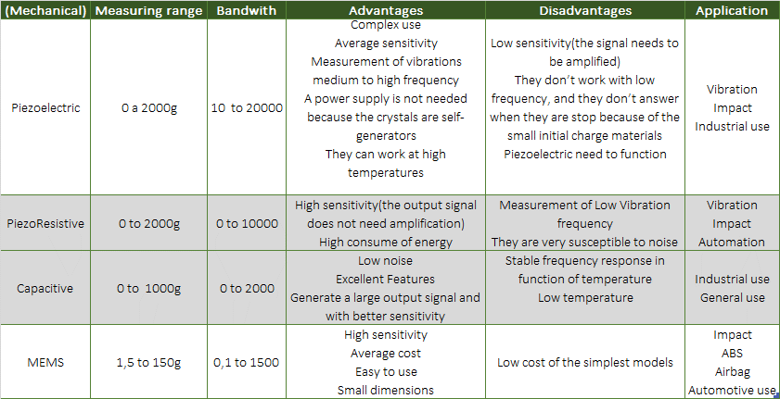
Types of accelerometers
Table 1 - Types of accelerometers

Which one is the best for vibration measurement?

Within the accelerometers those who are more used to calculate the vibrations are the piezoelectric accelerometer, the piezoresistive accelerometer and the MEMS.

Second Part

Components

These where the components we used in our project.
Transistor
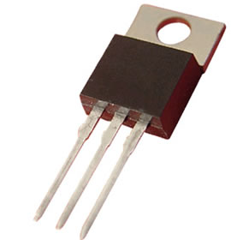 | The transistor is used to convert an electric tension to a lower electric tension. In this case to convert 5v in 3v.
Resistors
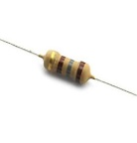  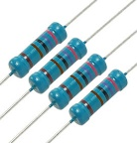  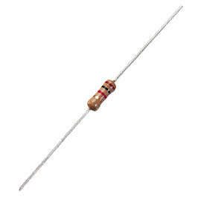 | The resistor is used to limit the electric current  (180 ohms, 2,7k and 1k).
Capacitor
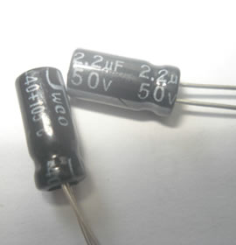  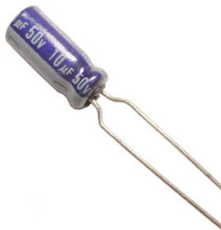 | The 2.2uf and the 10uf capacitor are used to block any DC bias.
LM324n
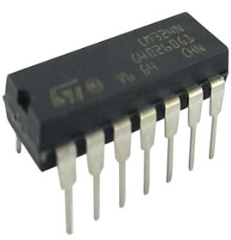 | The LM324n is a chip that has 4 ampops.
ADXL335
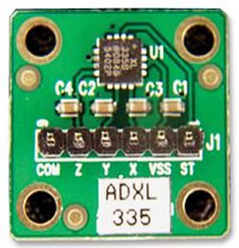 | The ADXL335 is a accelerometer that can be used for different things, in this case we will use it to detect vibration.
Max9814
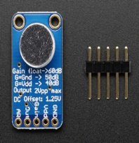 | The Max9814 is an automatic gain controller.
RGB
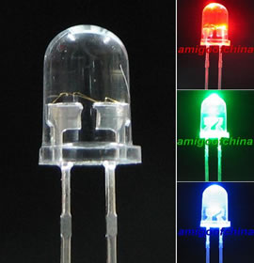 | The RGB is a Led with 3 different colours leds inside (Red, Green, Blue).
Jumper
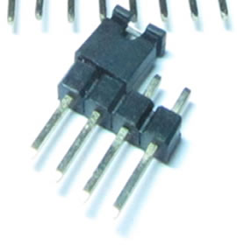 | The jumper is used to disconnect and connect a part off the circuit when we want too.
Power Jack
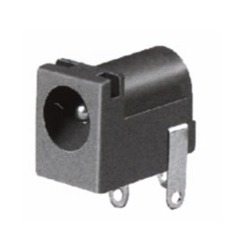 | The power jack is used to give current to a circuit and in this case will charge a battery.
Switch
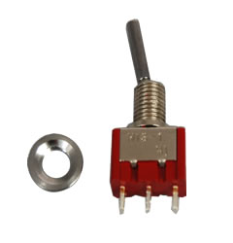 | The switch is used to turn on/off the circuit.
Socket
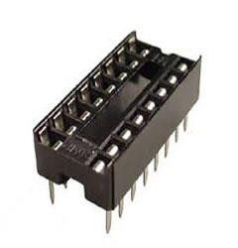 | The socket is used to support the chip, so you don’t waste the chip and can re-use it in other circuit.
Potentiometers
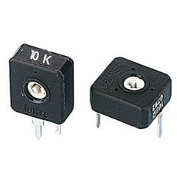  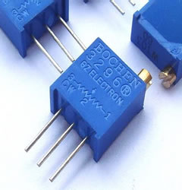 | The potentiometers are variable resistors and are normally used to regulate something. In this case 1 is used to regulate the transistor and other the ampop gain.
Pin Header (Fem-Male)
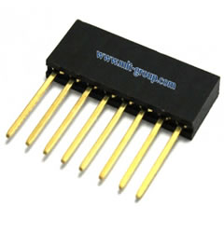  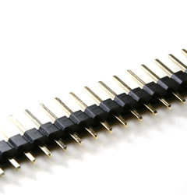 | The Pin headers are used to connect components.

Battery
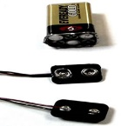 | The battery will be charged by the power jack and will give alimentation to Arduino Yun.
Arduino Yun
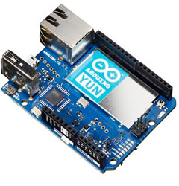 | This Arduino is similar to the others but this one as wireless.

BOM
Bill of materials or product structure (BOM)
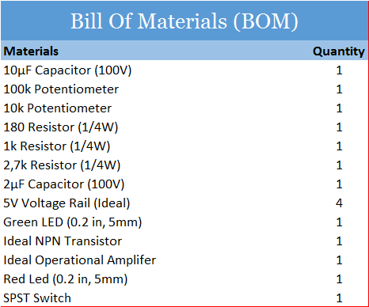

Circuits

Circuits schematic
Those were the circuits we made to our project.

Power Circuit
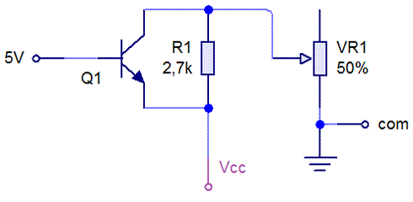
- This circuit is used to feed the Adxl335.
- Com/Vcc of Adxl335.
- The adxl335 can only receive 3v, this circuit converts the 5v(of Arduino) in 3v.

Ampop Circuit
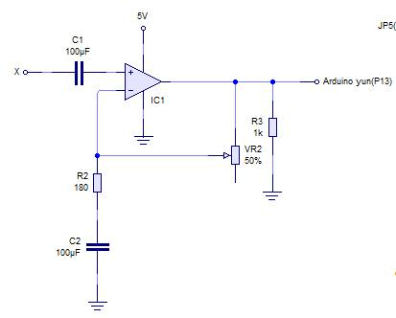

This circuit is used to amplify the frequency wave, because to Arduino reads it needs to have a bigger wave of frequency, this circuits as 56 of gain.
(Vr2 + R2)/R2

Alimentation Circuit of Battery
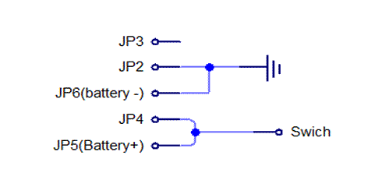
This circuit is used to charge the battery.

Alimentation Circuit of Arduino
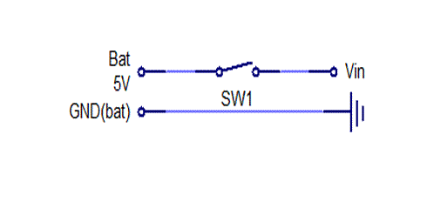
This circuit is used to give alimentation to Arduino Yun.

Circuit of Max9814
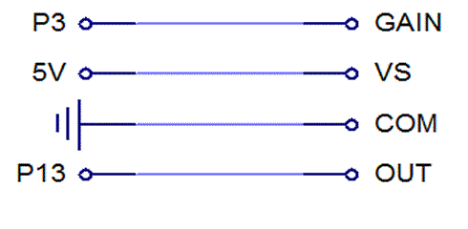
This circuit is the connection of Max9814.

Circuit of RGB
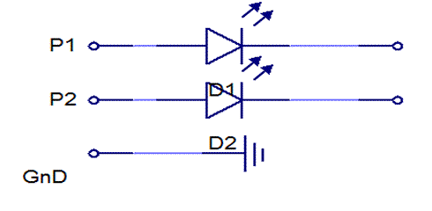
This circuit is the connection of the RGB.

Circuit Wizard Program

The software we used was Circuit Wizard (download).

Click an image to download circuit maker file used in this project.

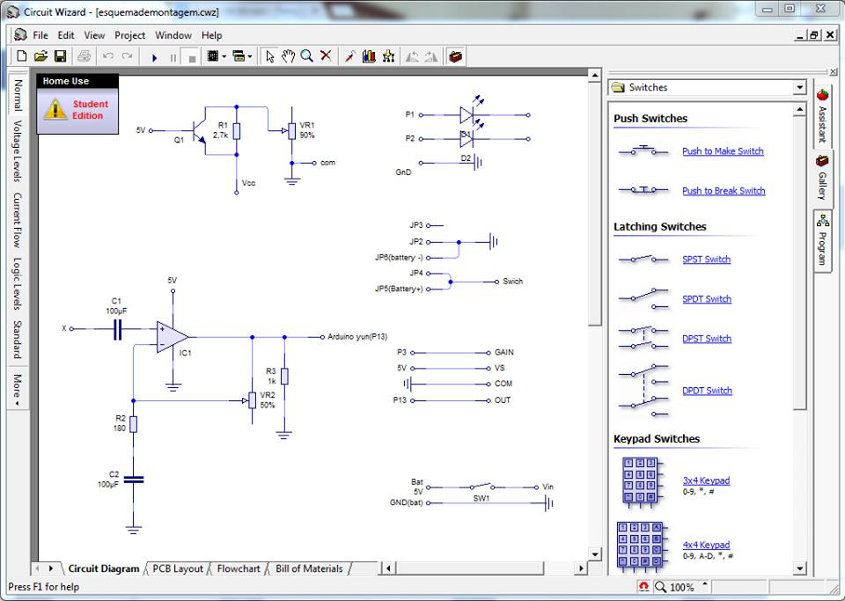

PCB – Printed Circuit Board

This was the Printed Circuit Board (PCB) we made to our project.

All | Names and values (without vias)
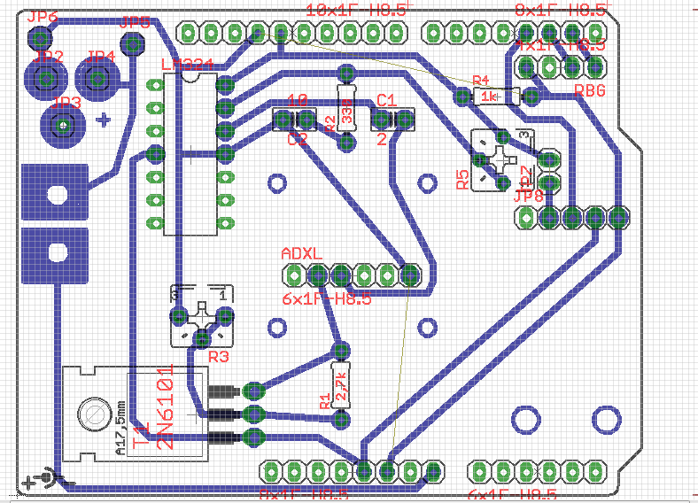 | 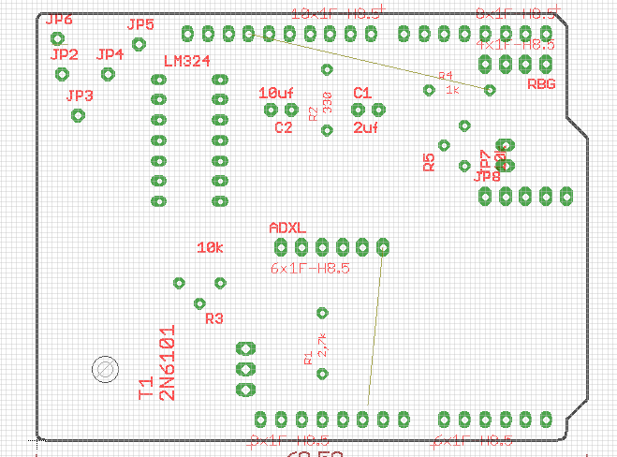

Only Vias | Place Only
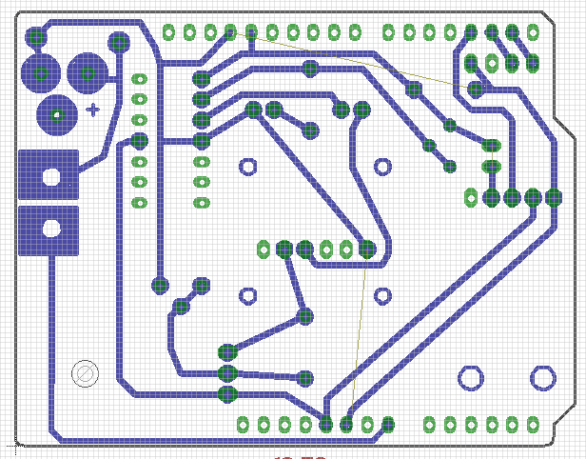 | 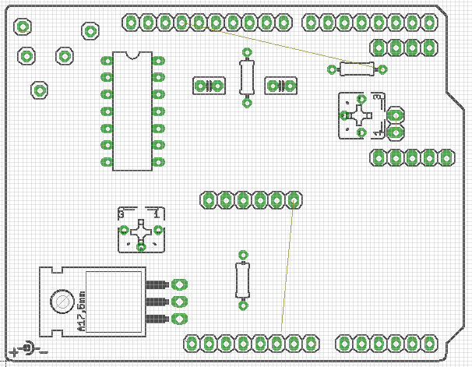

Eagle Program

The software we used was Eagle (download).

Click an image to download Eagle file used in this project.

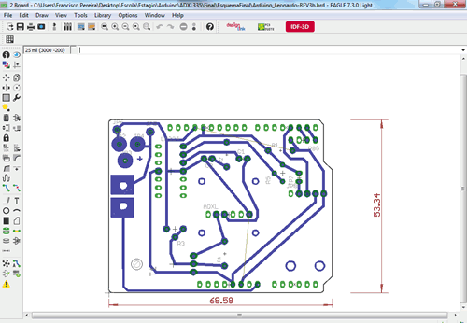

Third Part

Programming

Arduino Software

The software we used was Arduino Software (download).

FreqMeasure Library

We used the library named FreqMeasure (download).

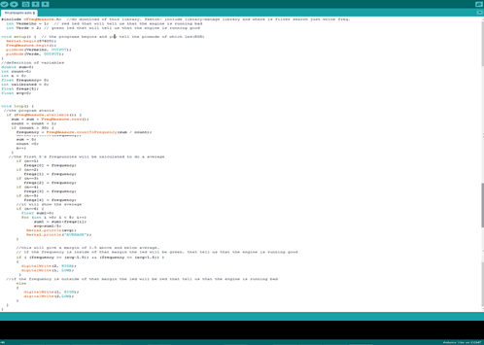
Click an image to download Arduino file (code) used in this project.

Online PHP Files

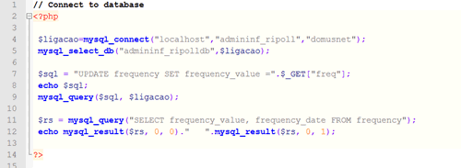
Click an image to download php file (connect PHP script to an existing MySQL database) used in this project.

Click an image to download php file (show the values from table frequency) used in this project.

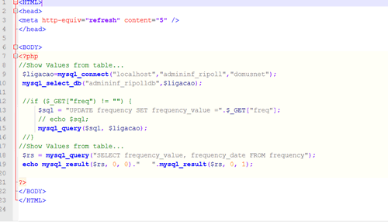

This was the Arduino we used in our project.
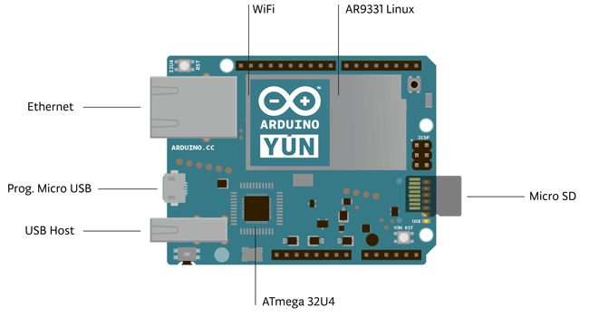

Videos Demonstration

Testing the programation in final circuit
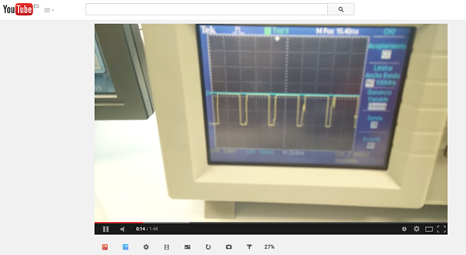

Checking the wave of frequency (checking harmonics) of the final circuit
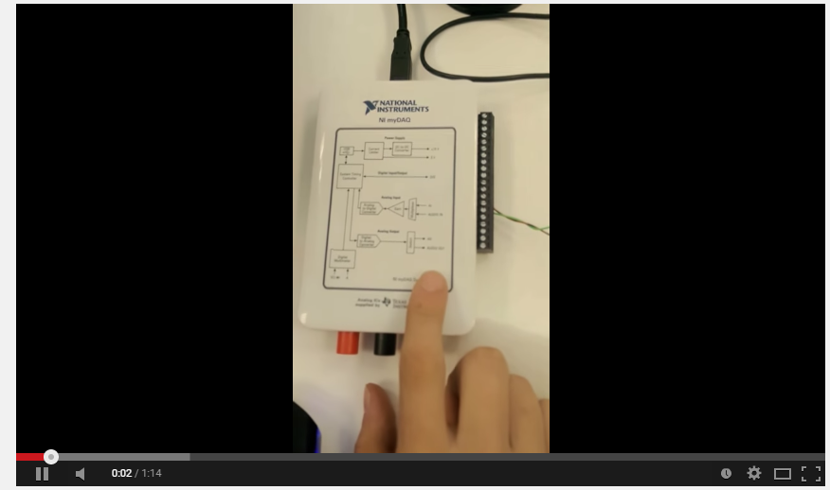

Fourth Part

Box Design
This was the box we made to put the Arduino and the battery inside.

Box
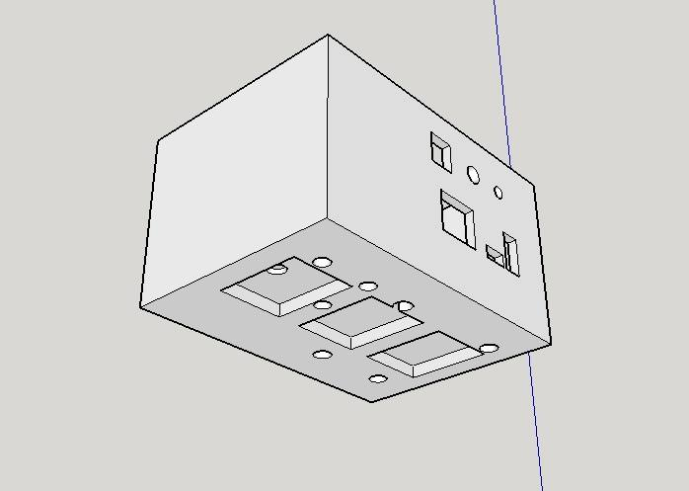

Box Cover

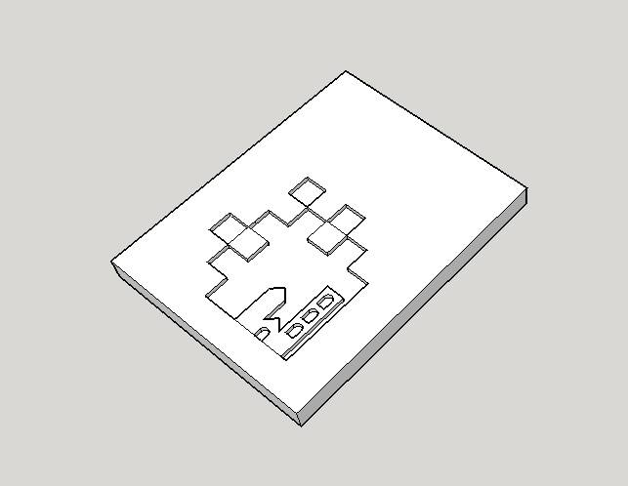

Sketchup Software
The software we used to design the box was Sketchup (download)

Click an image to download Sketchup file used in this project.
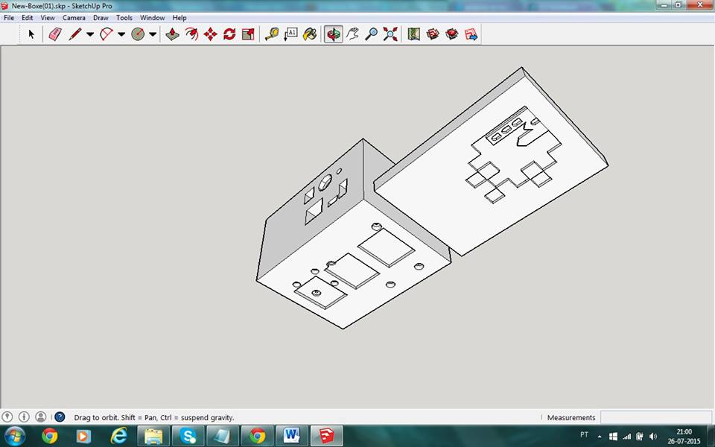

3d Printer Software
The software we used to print the box was the MakerBot (download)
Click an image to download MakerBot file used in this project.
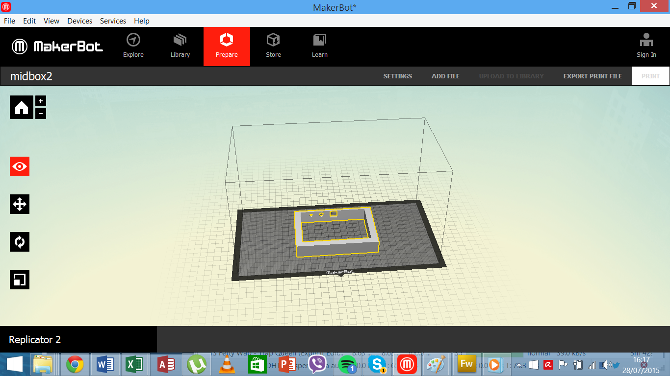

The box in the software of the 3D printer

Box:
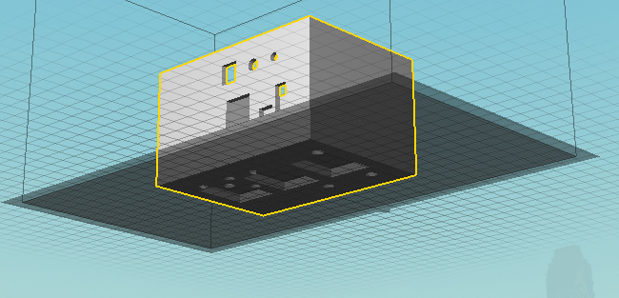

Box cover:
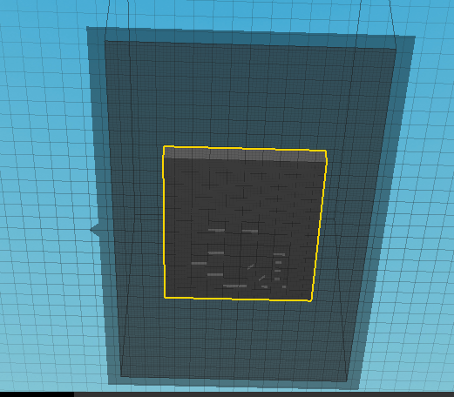

Fifth Part

Final Product
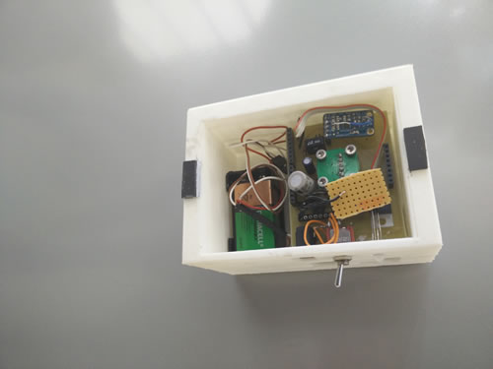
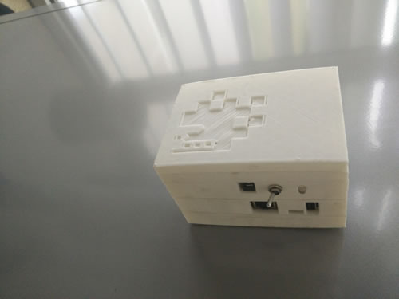
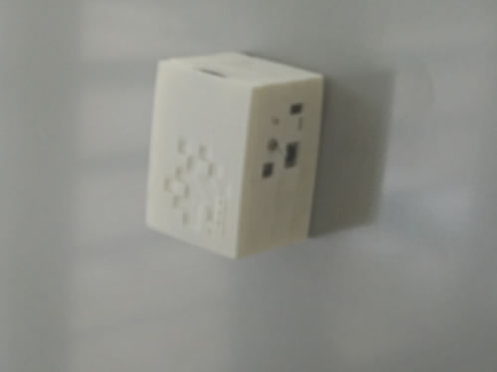
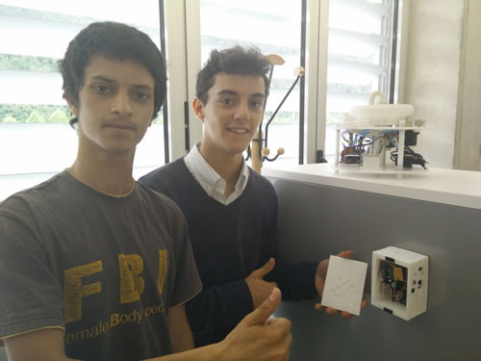

Sixth Part

Website

All the information will be available in the website (www.infatima.com/ripoll), the website was created in WordPress platform.

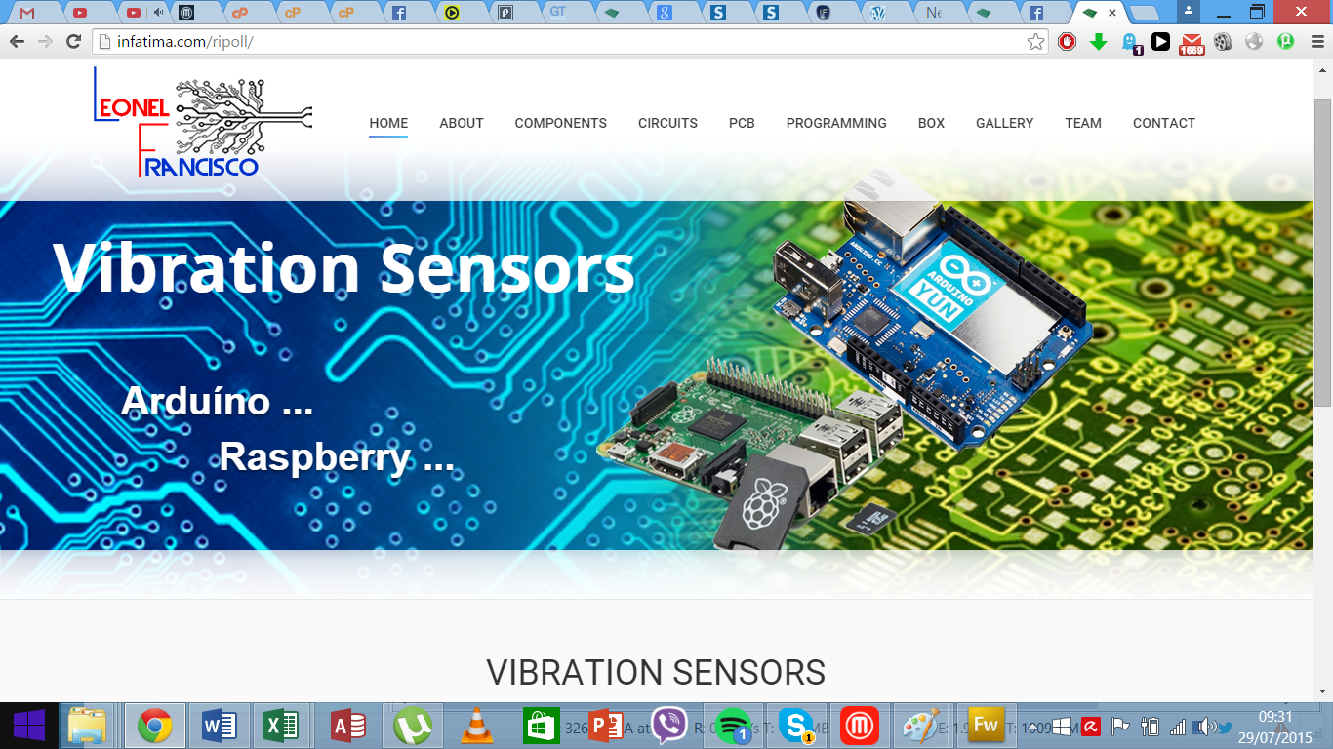

Seventh Part

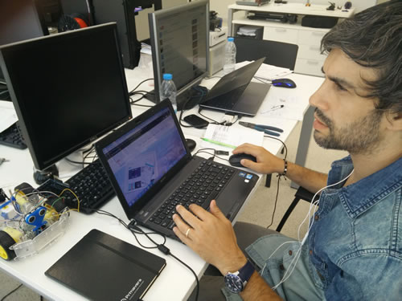
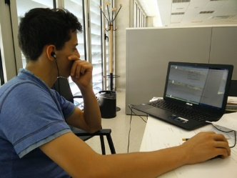
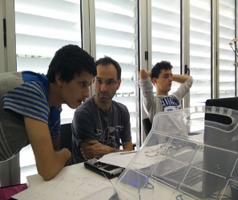
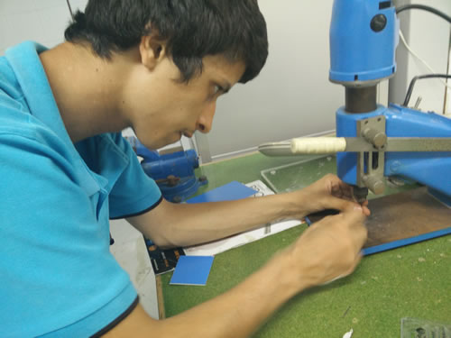
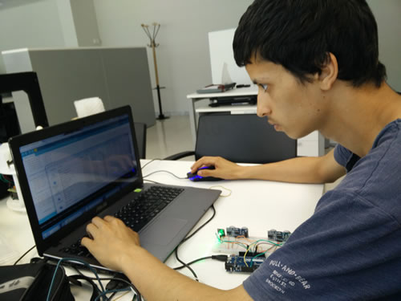
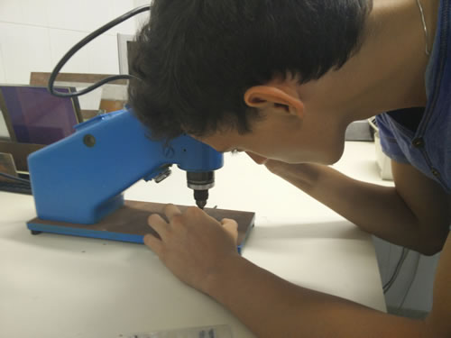
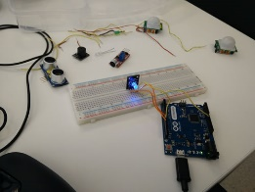
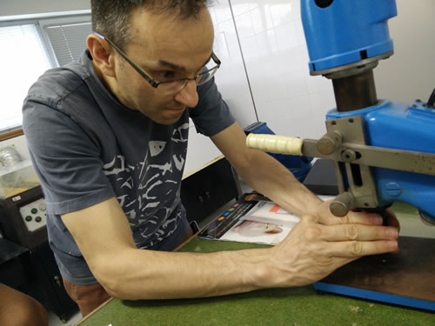
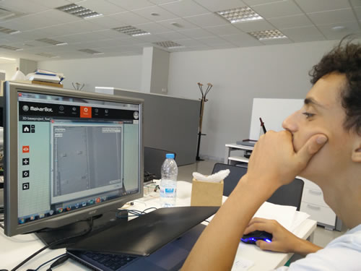
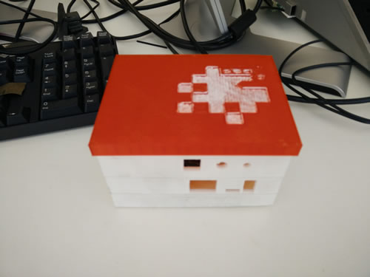
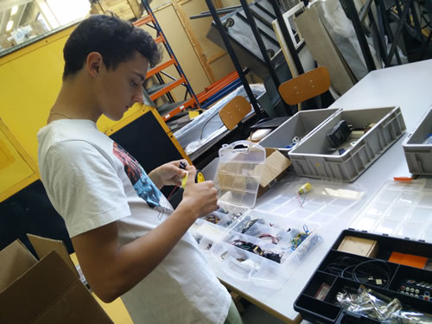
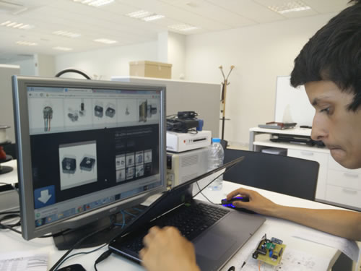
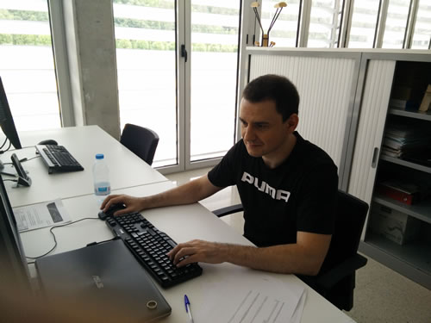
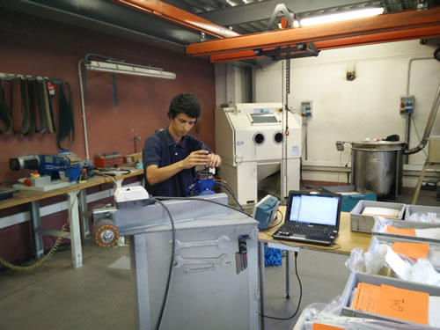
Gallery

Eight Part

Conclusion

The main objective of our project was to create a vibration sensor.
This sensor is a prototype and the information to continue it is available in the internet (www.infatima.com/ripoll).
Through the 2 months doing this project we have learned more about programation, we improved a few skills like electronic assembling and schematics.
We improved the technique of designing PCB and we improved the technique of drawing in a design software.
We improved the technique of welding.
We improved the technique of handle electronic instruments such as an oscilloscope and a frequency generator.
We improved our Spanish and the ability of communication with foreigners.
This type of project made us improve our skill at professional level but also as personal level.

